IT 350 – Final Lab Practical
This document describes the requirements for the Final Lab Practical Assignment in IT 350. You are expected to integrate and apply the networking technologies you have learned throughout the course to configure and verify a production-ready network. The steps below identify the required configuration tasks and verification evidence for this assignment.
You are a junior network technician working for an organization that operates across multiple locations. The company is preparing to deploy a new network infrastructure to support internal users, inter-site connectivity, and access to external resources. Your role is to complete the configuration and ensure the network is ready for production use in accordance with the provided requirements.
You have been provided with a two “site” topology connected by a provider router. You will not have, nor will you need, access to the provider router or to S1-SITE2. Various PCs are connected to the network. Complete each of the steps below to satisfy all requirements and achieve full connectivity between all PCs in the network.
 | Points Possible | Points Awarded
- Configure each of your routers and switches (NOT Provider Router, S1-SITE2, or the PCs) with a hostname. The hostname of each device should match the description label on the topology pallet. For example, the device labeled as S2-SITE1 on the topology view of PacketTracer should have a hostname of S2-SITE1. Add a screenshot of the output of the “show cdp neighbor” command from S1-SITE1 to show that you have completed this.
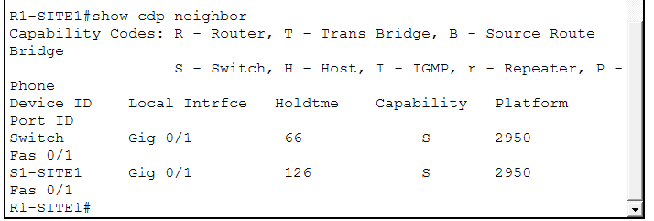 | 8
- Ensure that all interfaces are up at layer 1 and 2 so that you have ‘green’ status on all devices. Add a screenshot of the logical view of the Packet tracer window showing all interfaces with a green status.
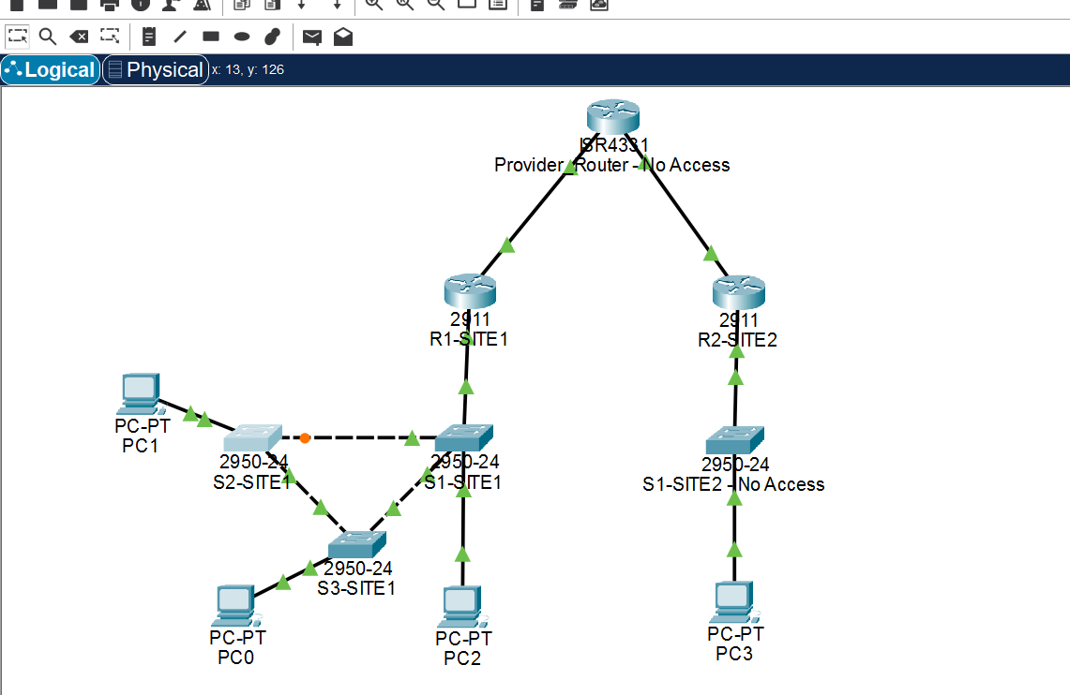 | 8
- Some addressing has already been configured for you. Some will need to be added. Configure IP addressing on your routers and switches as indicated below. Only use what you need and do not configure addressing that is not necessary:
  - R1-SITE1 is connected to the provider router. The provider has given you the subnet of 216.127.251.0/30. The provider is using the first available host address in this range. Configure an address for your interface, but DO NOT use an address the provider has selected.
  - All switches at SITE1 (S1-SITE1, S2-SITE1, and S3-SITE1) require an IP address for management. The subnet for this site is 192.168.0.0/24. Configure each VLAN1 interface on the switches with a usable IP address from the range. You can use any host address above .200 for this purpose. Switches should have full IP connectivity to other devices. Configure routes or default gateways as appropriate.
  - Add a screenshot of the “show ip int brief” command for each of the switches/routers that you configured.
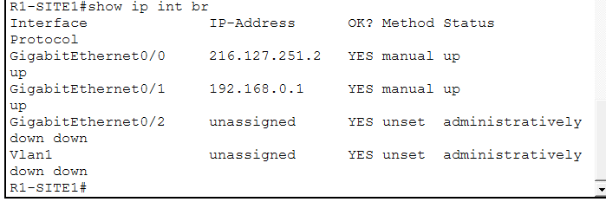  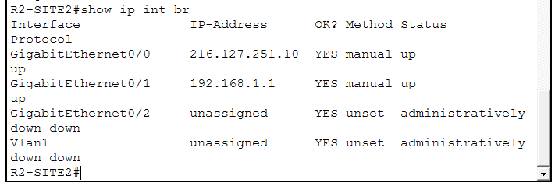  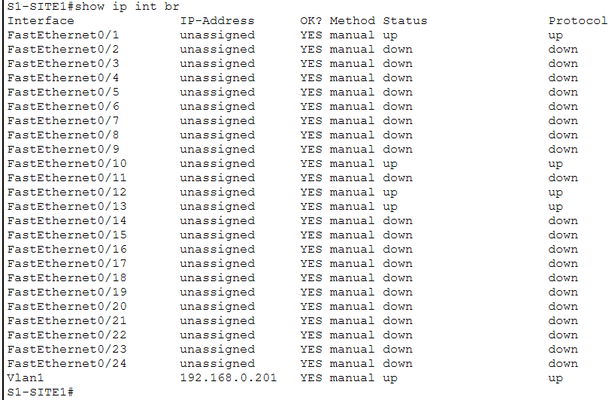  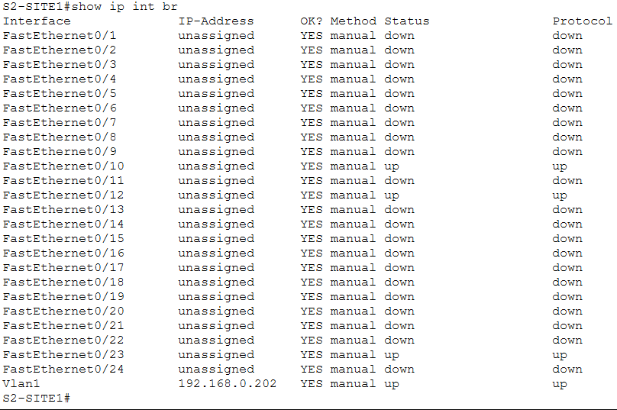  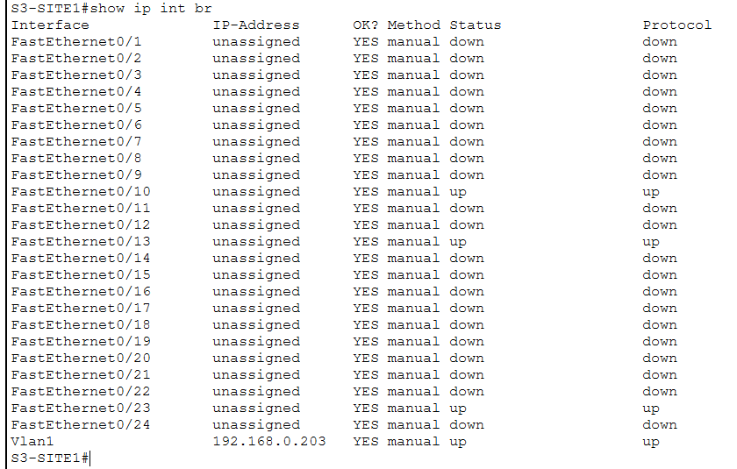 | 8
- You would like to implement a simple method of locally and remotely accessing your devices and to discourage unauthorized access. Ensure that the following is configured on each device:
  - Configure all your devices with an enable password. The password is cr3dit. The password should NOT be visible in the show run and should ALWAYS be hashed.
  - Configure your console password to be v@liant. This password DOES NOT need to be hashed in the show run.
  - Enable telnet on all your devices. Ensure that a password is required for access. The password to use for telnet access is CTR123. This password DOES NOT need to be hashed. Telnet should allow up to five simultaneous connections when you are done configuring.
  - Add a screenshot of the output of the command “show run | section line” from each of the devices you configured.
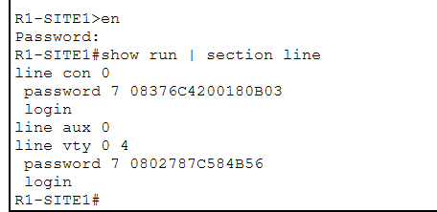  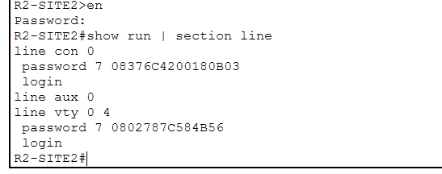  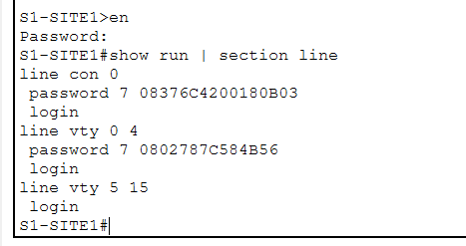  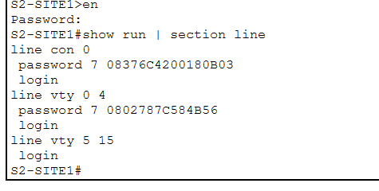  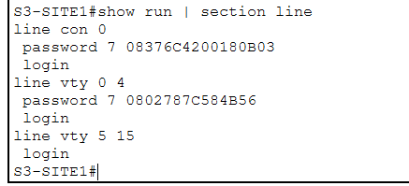 | 8
- Create a new VLAN 20 in your switch environment at SITE1 and name it ‘DEV’. Add it as an access port on the interface connected to PC0 connected to the S3-SITE1 switch. Ensure that this VLAN is available on all switches by whatever means you prefer. Also configure all uplinks between switches such that they can carry multiple VLANs. NOTE: when you do this, PC0 will lose IP connectivity to other devices. This issue will be resolved in subsequent steps. Add a screenshot of the output of the “show vlan” and “show int trunk” commands for each of the three switches.
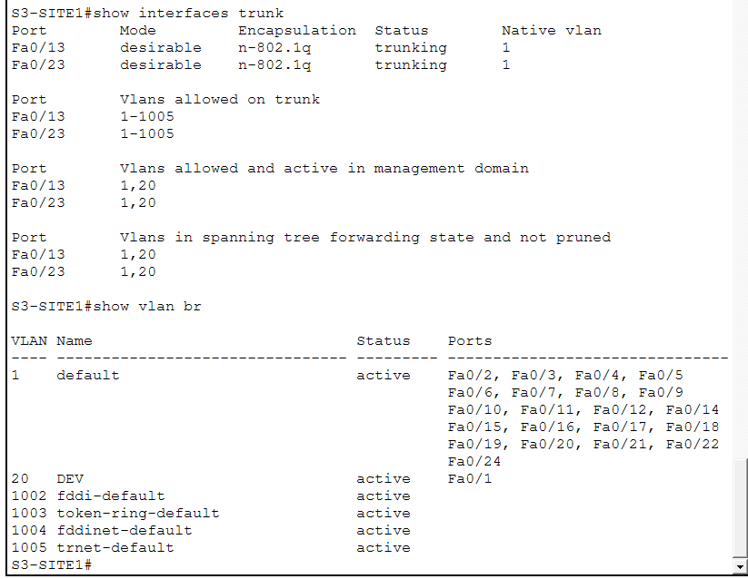  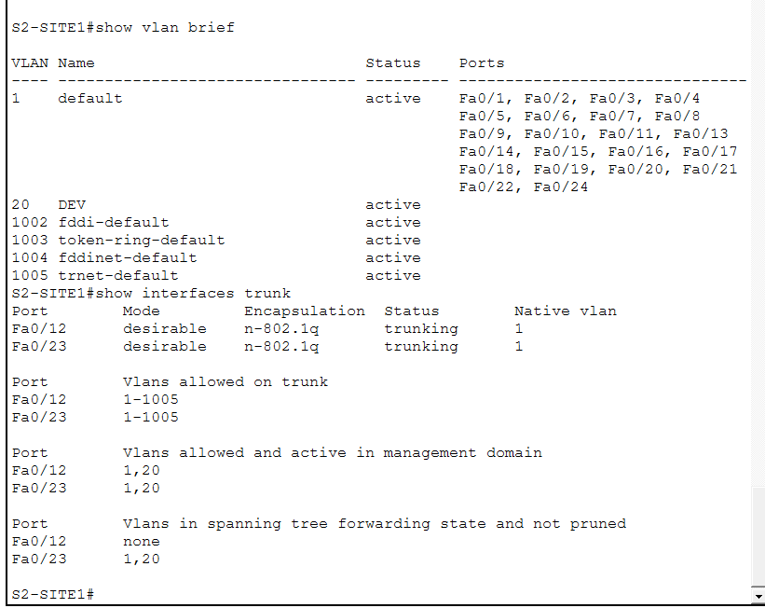  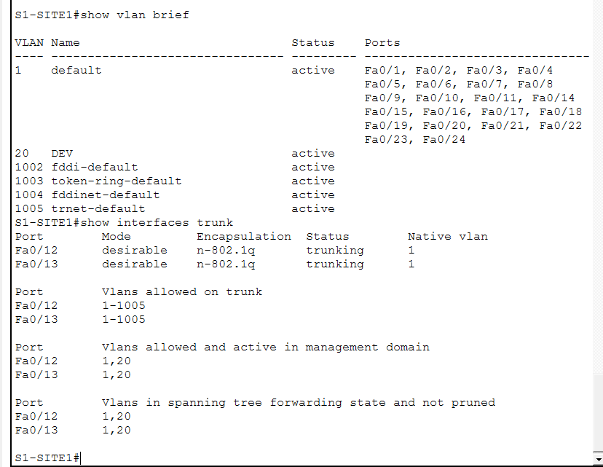 | 8
- You have been asked to use a subnet from the range 192.168.128.0/24 to support devices on VLAN 20. R1-SITE1 will perform InterVLAN routing between VLAN1 and VLAN20 at SITE1. Configure R1-SITE1 such that all devices on each VLAN can reach each other. Choose a subnet from the 192.168.128.0/24. Assume growth on the subnet up to no more than 100 hosts. Do not use the entire /24 for VLAN 20. Add a screenshot of the output of the “show run | section interface” command from R1-SITE1.
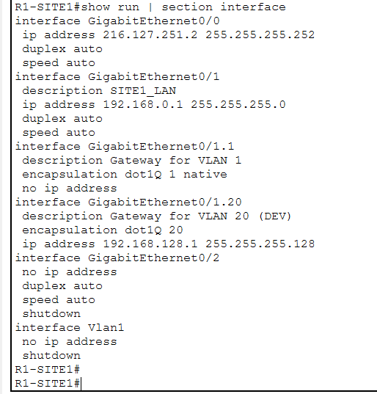 | 8
- PCs in VLAN 1 are already receiving DHCP from R1. Provide DHCP from R1 for the new subnet created in question #6. Be sure to exclude any addresses that are statically configured on the subnet. Add a screenshot of the of the “show run | section ip dhcp” command from R1-SITE1.
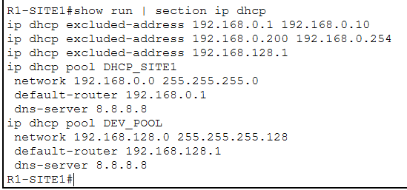 | 8
- The WAN interface on R1-SITE1 should be configured for source NAT and should overload (or PAT) all traffic coming from the internal networks to the outside interface (GE0/0) IP before being sent to the provider router. NOTE: don’t forget to consider all the subnets for all VLANs. Add a screenshot of the output of the “show run | section ip nat” and “show ip nat statistics” commands from R1-SITE1.
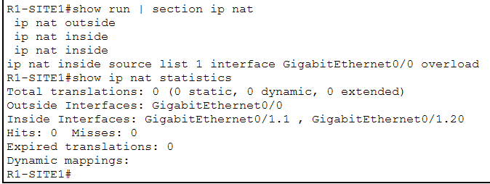 | 8
- Configure a static default route on R1-SITE1 pointed to the Provider_Router. Only configure what you need so that the Provider Router is the next hop for all traffic that is not 192.168.0.0/24. Add a screenshot of the output of the “show ip route” command from R1-SITE1.
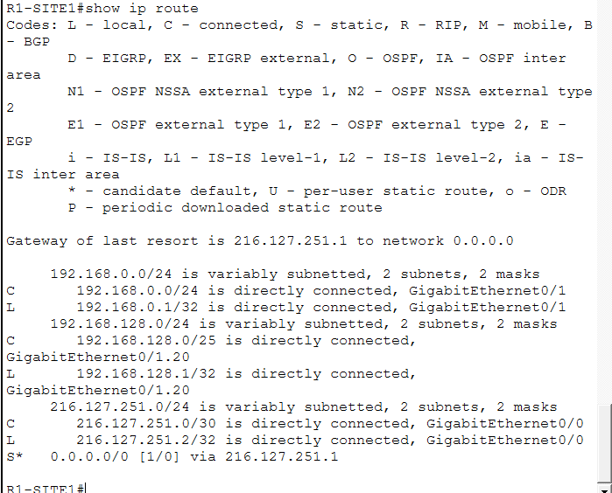 | 9
- R2-SITE2 is mostly configured but requires that OSPF be added so that it can form a neighbor relationship with Provider_Router. Provider_Router is already configured for OSPF in area 0. Adding the appropriate OSPF configuration to R2-SITE2 such that it advertises all connected subnets, forms a neighbor relationship with Provider_Router over GE0/0 and does not send any OSPF hello packets out the LAN interface (GE0/1). Add a screenshot of the output of the “show ip ospf interface” command from R2-SITE2.
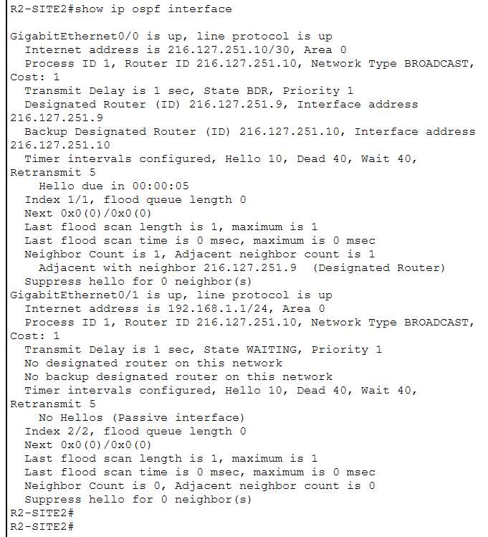 | 9
- Add redundant links between S1-SITE1 and the other two switches at SITE1 and configure channel groups using the protocol of your choice. Add a screenshot of the logical view of the Packet tracer window showing the redundant links with a green status.
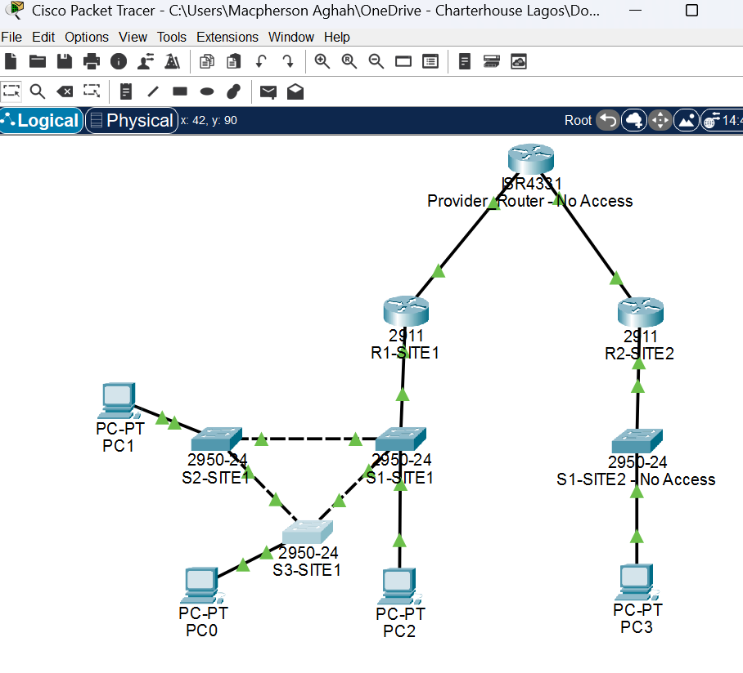 | 9
- Configure Spanning Tree Protocol such that all traffic flows towards S1-SITE1 as the root of the layer 2 network even if additional switches with a default configuration are added in the future. Add a screenshot of the output of the “show spanning-tree” command from S1-SITE1.
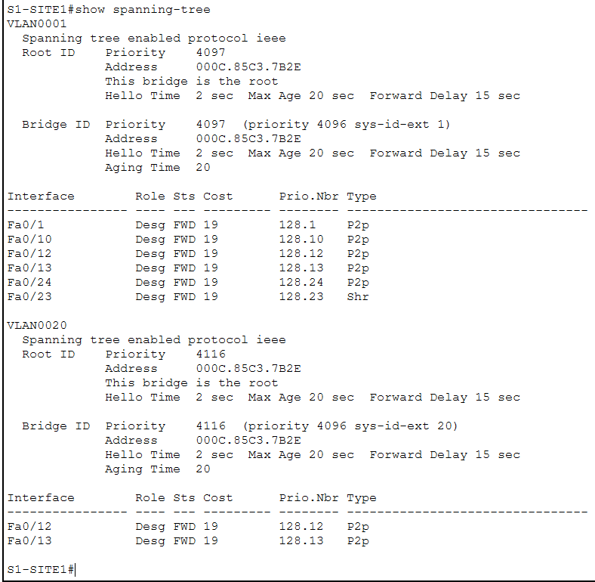 | 9
- Save your show run on your routers and switches with a “wr mem” command and copy them to a text file. Upload the ‘show run’ for all devices that you can access (R1-SITE1, R2-SITE2, S1-SITE1, S2-SITE1 and S3-SITE1) to Canvas. Also upload a copy of your saved PacketTracer file.
Total Points | 100

